Oracle Employee Profile

Please complete the following items and return back to
ABS Human Resources in Singapore

People Page

Surname: | Joshi
First Name: | Rajashree
Title: | Miss
Middle Name: | Achyut
Gender (male/female): | Female
Date of Employment: | 10/06/2015
NRIC / Passport No./ ID No. OR Social Security No.  (please specify which document ID you are providing): | NO352566
Date of Birth: | 08/02/1994
Town of Birth: | Nashik
Country of Birth: | India
Nationality / Citizenship: | Indian
Marital Status (single/married): | Single
Disability (yes/no): | No
Ethnic Origin:
Blood Type: | B+

Current Home or Correspondence Address (MANDATORY FIELD)

Line 1: | C01, Shivraj Complex,
Line 2: | Behind Vaibhav Theatre
Line 3: | Hadapsar
Line 4: | 411 028
Line 5:
Effective Date: | 01/10/2017

Please list the following telephone numbers:

Home Telephone:
Home Fax:
Mobile Personal: | +91 9922745492
Mobile Work:

Assignment Page

(*TO BE COMPLETED BY NEW HIRE’S LOCAL OFFICE)

HR Organisation (e.g. Singapore Port): | Singapore
Location: | Pune, India
Position:
Full-Time or Part-Time | Full-Time
Regular or Contractor
Sub-contracted Technical:
(Pls indicate accordingly)
Job Grade:
Supervisor/Timecard approval:

OTL Access:

Special Information Page

College/University Education:

Degree/Diploma Type: | Diploma [Full Time]
Graduation Year: | 2012
Name College/University: | Maharashtra Board of Technical Education [K.K.Wagh Polytechnic, Nashik]
Major: | Computer Engineering
Degree/Diploma Type: | Degree [Full Time]
Graduation Year: | 2015
Name College/University: | University of Pune [Vishwakarma Institute of Information Technology]
Major: | Computer Engineering

Degree/Diploma Type:

Graduation Year:
Name College/University:
Major:

Prior Work Experience (Before ABS):

Company Name: | BNY Mellon Technology Pvt Ltd [formerly iNautix Technologies Pvt Ltd]
Start Date: | 10/06/2015
End Date: | 06/11/2018
Position: | Senior Application Developer
Years in Position: | ~1 Year
Termination Reason: | Current Project is completed.

Company Name:
Start Date: | dd/mm/yyyy
End Date: | dd/mm/yyyy
Position:
Years in Position:
Termination Reason:

Company Name:
Start Date: | dd/mm/yyyy
End Date: | dd/mm/yyyy
Position:
Years in Position:
Termination Reason:

Languages:
Please list any languages you are proficient in:

Language Name |  | Proficiency (Native, Fluent, Written, Spoken or Read)
1. | Marathi | 1. | Native
2. | English | 2. | Fluent
3. | Hindi | 3. | Fluent

Other Information Page

Please add Emergency Contact (MANDATORY FIELD):

Surname: | Joshi
First Name: | Achyut
Middle Initial: | G
Title: | Mr.
Address Line 1: | Kulprakash, Chandreshwar Society,
Address Line 2: | Shikharewadi, Nashik Road
Address Line 3: | Nashik
Address Line 4: | 422 101
Address Line 5:
Date of Birth: | 05/05/1954
Relationship: | Father
NRIC / Passport No./ ID No. OR Social Security No.
(please specify which document ID you are providing):
Emergency Contact No: | +91 9225107618
Beneficiary (yes/no):

Please add Any Dependents:

Dependent #1
Surname: | Joshi
First Name: | Tejashree
Middle Initial: | A.
Title: | Ms.
Address Line 1: | Kulprakash Chandreshwar Society,
Address Line 2: | Shikharewadi, Nashik Road,
Address Line 3: | Nashik
Address Line 4: | 422 101
Address Line 5:
Date of Birth: | 27/02/1989
Relationship:
NRIC / Passport No./ ID No. OR Social Security No.
(please specify which document ID you are providing):
Beneficiary (yes/no):

Dependent #2

Surname:
First Name:
Middle Initial:
Title:

Address Line 1:
Address Line 2:

Address Line 3:
Address Line 4:
Address Line 5:
Date of Birth: | dd/mm/yyyy
Relationship:
NRIC / Passport No./ ID No. OR Social Security No.
(please specify which document ID you are providing):
Beneficiary (yes/no):

Dependent #3

Surname:
First Name:
Middle Initial:
Title:

Address Line 1:
Address Line 2:

Address Line 3:
Address Line 4:
Address Line 5:
Date of Birth: | dd/mm/yyyy
Relationship:
NRIC / Passport No./ ID No. OR Social Security No.
(please specify which document ID you are providing):
Beneficiary (yes/no):

If you need to add any further Dependents, please write them on a blank piece of paper and attach it to this profile.

Picture Page

Please enclose a recent passport-size (in colour) photograph for scanning into our Oracle System.

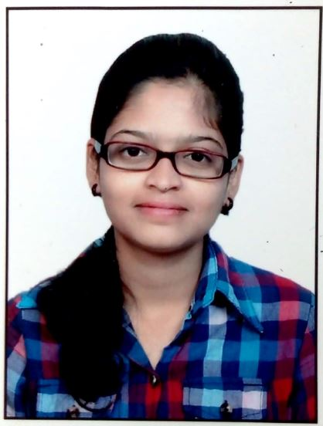
Passport Photograph Size enclosed: _______Yes__________(Yes/No)

